**Industrial Internship Report on**

**”Online Education System using Cloud computing”**

**Prepared by**

**DEVADUTTA B R**

|  |
| --- |
| *Executive Summary* |
| This report provides details of the Industrial Internship provided by upskill Campus and The IoT Academy in collaboration with Industrial Partner UniConverge Technologies Pvt Ltd (UCT).  This internship was focused on a project/problem statement provided by UCT. We had to finish the project including the report in 6 weeks’ time.  My project is Topic Online Education System using Cloud computing.  It is the delivery of learning and training through digital resources. Although eLearning is based on formalized learning, it is provided through electronic devices such as computers, tablets and even cellular phones that are connected to the internet. This makes it easy for users to learn anytime, anywhere, with few, if any, restrictions. Basically, eLearning is training, learning, or education delivered online through a computer or any other digital device.  This internship gave me a very good opportunity to get exposure to Industrial problems and design/implement solutions for that. It was an overall great experience to have this internship. |

**Table Of Contents**

1. Preface…………………………………………………………………………………………………….3
2. Introduction ………….………………………………………………………………………………..6
   1. About Uniconverge Technologies Pvt Ltd ……………………………………….6
   2. About Upskill campus(USC) …………………………………..……………………………………...9
   3. Objectives …………………………………………………………………………………………11
   4. Reference…………………...........................................................................12
3. Problem Statement ………..………………………………………………………………………13
4. Proposed work ..................……………………………………………………………………..14
5. Proposed Project Introduction……..…………………………………………………………15
   1. Overall Description ………………………..…………………………………………………16
   2. User List ……………………………………………………………………………………………17
6. E-Learning………………………………………………….……………………………………………18
7. Software Design …………………………………….……………………………………………….20
8. Software Testing ………………………………………………….…………………………………24
9. Conclusion ……………………………………………………………………………………………..26
10. Future scope …………………………………………………………………………………………27

# Preface

**Week :** We studied what the topic was about, then took some notes while we studied pros and cons of the topic, then we started to write a code then implemented it in the software.

**1.What is online education?**

Online education refers to a method of carrying out teaching and learning processes through technology. Students and teachers make use of internet technology to experience learning opportunities outside the vicinity of a traditional classroom. Students and teachers interact with each other through options like virtual classes/sessions, Chabot’s, emailing, messaging, etc.

We all know that the pandemic has given a boost to the e-learning market. But do you know the exact growth rate of this market in India?

Before we discuss more about online education advantages and disadvantages, here’s a look at some quick facts about the growth of the e-learning market in India:

* There has been stupendous growth in the e-learning market in India in the past 6 years. The value of the Indian e-learning market was [39 billion](https://www.statista.com/statistics/1290720/india-e-learning-market-value/) rupees by the year 2018. And this figure is estimated to increase to a massive 360 billion rupees by the year 2024.

. 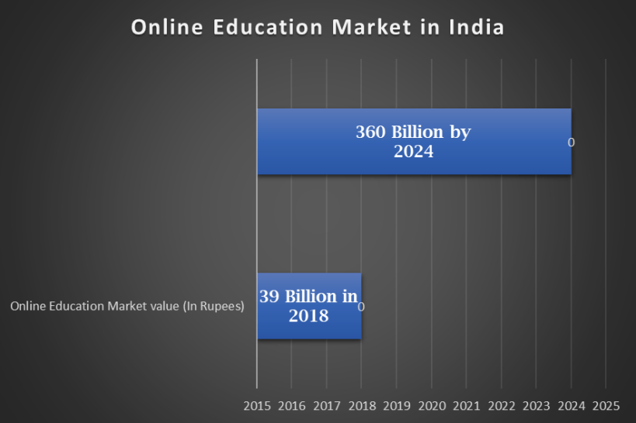

* The net worth of this market expanded at a CAGR of [44%](https://www.indiatvnews.com/education/news-online-education-industry-witnesses-massive-surge-how-virtual-classes-can-improve-state-of-education-in-rural-areas-668385) between 2014 to 2019 and 43% from 2019-2024.

In the years to come, India will have a bigger market for virtual education. The Ministry of External Affairs, Government of India highlights that India is on the way to becoming a virtual education market worth [$313 billion](https://indbiz.gov.in/india-to-become-313-billion-education-market-by-2030/) by the year 2030. With this, online education platforms, along with the skills market will grow double in a decade’s time, thereby impacting 429 million learners.

**Advantages of Online Education**

**Inclusivity –**Many times students with special needs are overlooked in policies. But with a massive population of almost [240 million](https://www.unicef.org/education/inclusive-education) disabled children in the world, inclusivity is certainly a big concern across the globe. Like distance learning, online study too benefits disabled students immensely. It helps them to develop skills by eliminating all barriers to learning.

**Better Accessibility and teacher quality-** With only a stable internet connection, and a device, an online school can bring the best quality educational content right to the doorstep of a student. In a country like India, where [65%](https://www.indiatoday.in/education-today/featurephilia/story/india-rural-education-problems-958214-2017-01-31) of the population resides in rural areas, accessibility is a huge problem.Digital learning also resolves the problems of teacher quality (such as accountability, untrained, absenteeism, poor knowledge of appropriate pedagogies, etc.).

**Flexibility and pacing options-**The Merits of Online Classesalso include the freedom to plan, create, design, or follow any study pattern as per one’s lifestyle or preference. This importance of online education empowers students to spend more or less time on a topic as per their individual need. they do not have any compulsion to match the pace of any other student, unlike a regular classroom.

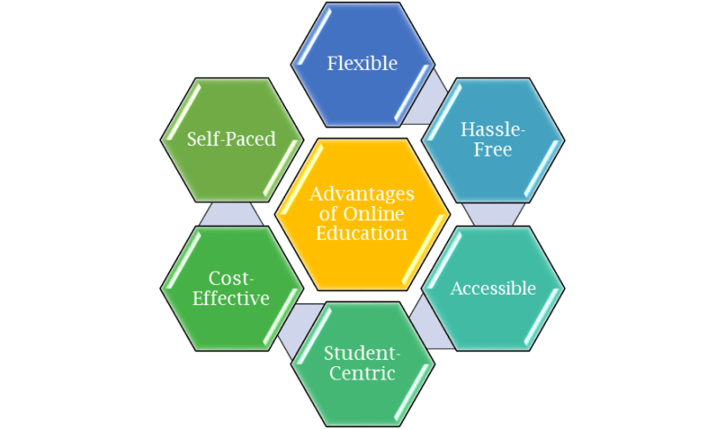

**Disadvantages of Online Education**

**Dependence on technology**– Digital divide, internet [literacy](https://onlineschoolsindia.in/school-guide/top-10-most-literate-states-in-india/), and the availability of a supported device are barriers to this medium. India ranked [73](https://www.statista.com/statistics/1232343/internet-literacy-index-by-category-india/) out of 120 countries in internet literacy. And reports revealed that [50%](https://timesofindia.indiatimes.com/readersblog/thewordsmith/digital-democracy-the-missing-link-in-indias-digital-aspirations-34401/) of our population had no access to the internet. Despite the alarming state, Indian policymakers have found a way to work on these issues. Our government has created some great action plans to curb the digital divide. And [initiatives](https://pib.gov.in/pressreleasepage.aspx?prid=1812277) like ‘National Digital Literacy Mission’, ‘Digital Saksharta Abhiyan’ and ‘Pradhan Mantri Gramin Digital Saksharta Abhiyan’ etc. (By Niti Aayog) are already targeting a huge fraction of the Indian population (more than 6 crores).

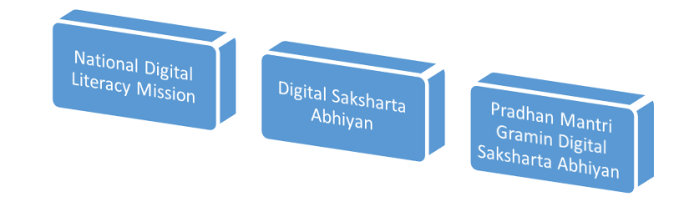

**Distractions**– Another flip side of an online learning center is that a student can easily get distracted. While some educationalists like to believe this fact, it is still debatable. In a virtual learning environment, a student’s motivation, monitoring, and engagement are subject to many factors. In fact, some online education platforms have challenged this belief and proved it as a myth. Reports have proved that [85%](https://www.forbes.com/sites/brandonbusteed/2019/03/05/online-education-from-good-to-better-to-best/?sh=715b82496912) of students who had enrolled in both traditional and virtual learning institutions found the latter either the same or better than classroom learning.

**Despite the pros and cons of online education, the virtual learning movement is here to stay!** Opportunity given by USC/UCT.

They provided us with a quiz so that it was helpful to know whether the content is understood or not. If the score was less, then we used to watch those videos repeatedly so that concept should be clear to us.

Program was planned very well as per schedule in the time table provided.

Overall the internship was helpful and made me understand the concept clearly.

Thanks to all mentors like Ankit, Apurv and all coordinators, who have helped me directly or indirectly.

The message I gave to my Juniors was “ Be independent, take your own decisions, do not run with the herd. Do follow instructions and complete work on schedule.”

# Introduction

## About UniConverge Technologies Pvt Ltd

A company established in 2013 and working in the Digital Transformation domain and providing Industrial solutions with prime focus on sustainability and RoI.

For developing its products and solutions it is leveraging various**Cutting Edge Technologies e.g. Internet of Things (IoT), Cyber Security, Cloud computing (AWS, Azure), Machine Learning, Communication Technologies (4G/5G/LoRaWAN), Java Full Stack, Python, Front end**etc.



1. **UCT IoT Platform (****)**

**UCT Insight** is an IOT platform designed for quick deployment of IOT applications at the same time providing valuable “insight” for your process/business. It has been built in Java for backend and ReactJS for Front end. It has support for MySQL and various NoSql Databases.

* It enables device connectivity via industry standard IoT protocols - MQTT, CoAP, HTTP, Modbus TCP, OPC UA
* It supports both cloud and on-premises deployments.

It has features to  
• Build Your own dashboard  
• Analytics and Reporting  
• Alert and Notification  
• Integration with third party application(Power BI, SAP, ERP)  
• Rule Engine

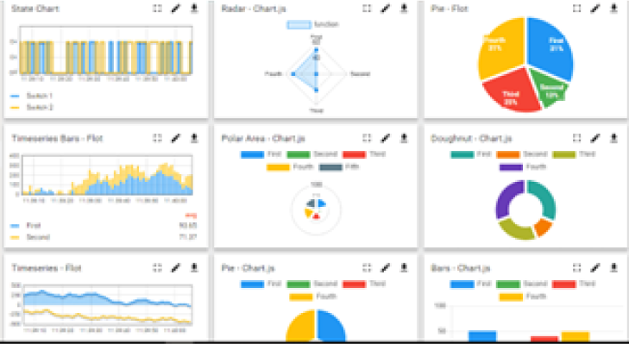

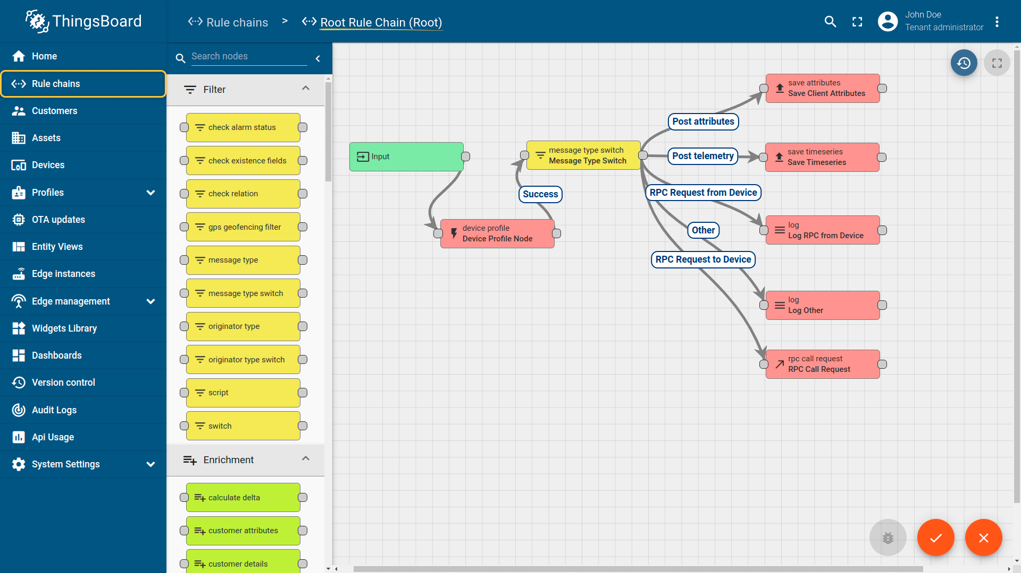

1. **Smart Factory Platform (**  **)**

Factory watch is a platform for smart factory needs.

It provides Users/ Factory

* with a scalable solution for their Production and asset monitoring
* OEE and predictive maintenance solution scaling up to digital twin for your assets.
* To unleash the true potential of the data that their machines are generating and helps to identify the KPIs and also improve them.
* A modular architecture that allows users to choose the service that they what to start and then can scale to more complex solutions as per their demands.

Its unique SaaS model helps users to save time, cost and money.

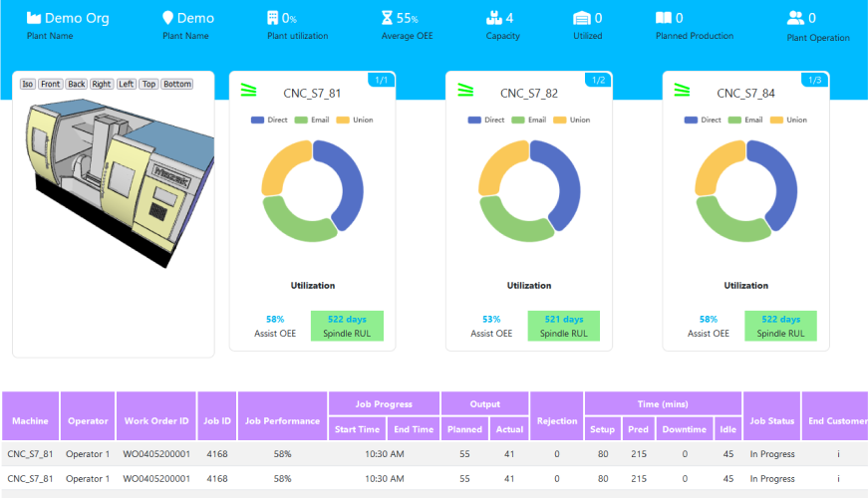

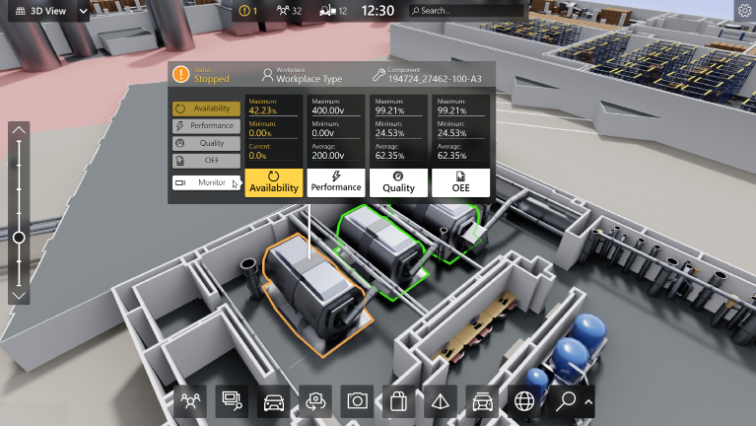

1.  based Solution

UCT is one of the early adopters of LoRAWAN technology and provides solutions in Agritech, Smart cities, Industrial Monitoring, Smart Street Light, Smart Water/ Gas/ Electricity metering solutions etc.

1. **Predictive Maintenance**

UCT is providing Industrial Machine health monitoring and Predictive maintenance solution leveraging Embedded system, Industrial IoT and Machine Learning Technologies by finding Remaining useful life time of various Machines used in production process.

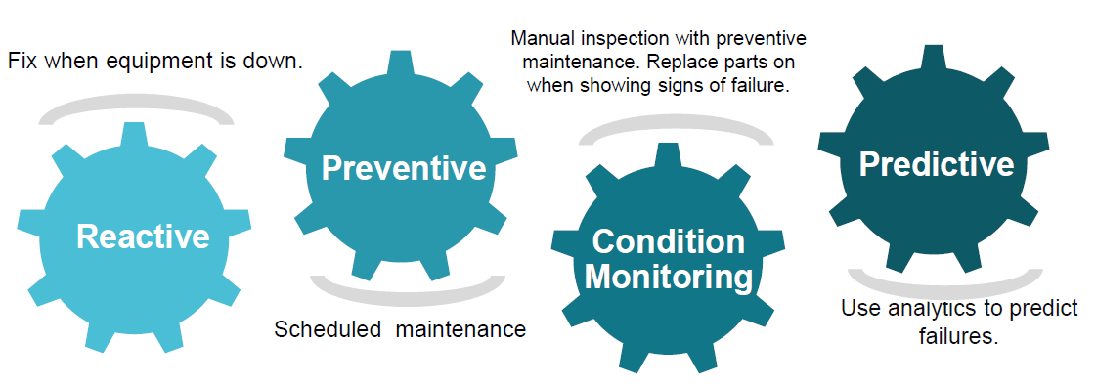

## About upskill Campus (USC)

upskill Campus along with The IoT Academy and in association with Uniconverge technologies has facilitated the smooth execution of the complete internship process.

USC is a career development platform that delivers **personalized executive coaching** in a more affordable, scalable and measurable way.

Smart technologies are rapidly changing the overall educational framework in the country. Did you know that it is projected the online market in India will grow to about $ 1.96 billion by 2021? It is a compound annual growth of about 52% from 2016, when the online education market was worth $247. It is estimated that there is a 175% increase in the cost of classroom education, this gives online education more preferred because it is cost effective.

The penetration of digital education into the hinterland / rural market is evolving fast. The situation in rural areas is troubling – outdated teaching methods, shortage of teachers, inadequate student-teacher ratio, and insufficient teaching resources are some of the issues they are still struggling with. But thanks to affordable high-speed internet and direct-to-device technologies, these are empowering rural students to study courses online and improve their skills and knowledge. Students in educationally backward areas are being taught with the aid of the latest teaching tools and methodologies. Technology has also helped teachers connect with students remotely spread across wide geographical locations. Interactive digital media will certainly help in addressing the shortage of teachers in the country in the near future.

But in a country as diverse as India in terms of regional, linguistic, caste, class and gender, and socioeconomic status, it creates a myriad of problems about specific educational, psychosocial and financial needs of students as well as teachers. A unilateral approach to digital learning isn’t the answer – the transition won’t happen at one-go or be smooth. However, there is tremendous opportunity for growth, and this is the perfect time to tap into it!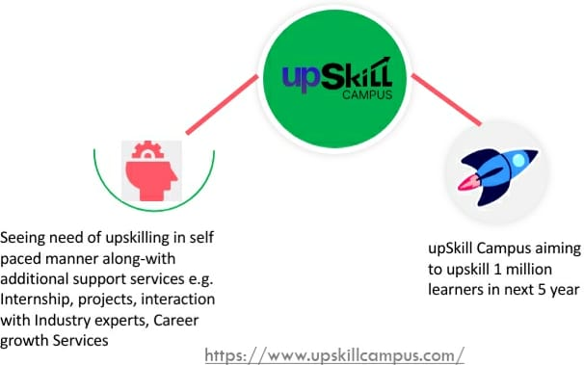

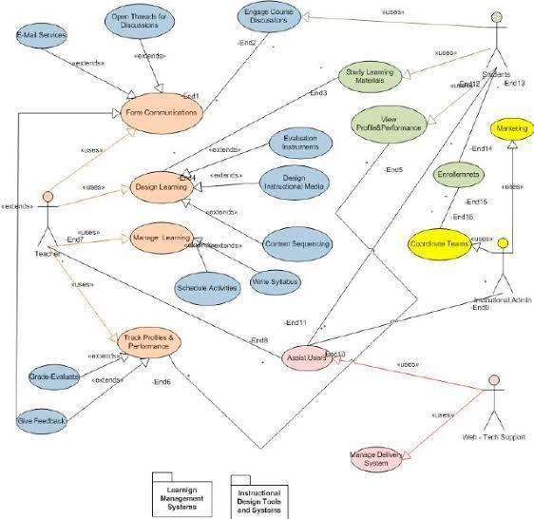



## The IoT Academy

The IoT academy is the EdTech Division of UCT that is running long executive certification programs in collaboration with EICT Academy, IITK, IITR and IITG in multiple domains.

## Objectives of this Internship program

The objective for this internship program was to

 ☛ get practical experience of working in the industry.

 ☛ to solve real world problems.

 ☛ to have improved job prospects.

 ☛ to have Improved understanding of our field and its applications.

 ☛ to have Personal growth like better communication and problem solving.

## Reference

1. Poonam R.Maska et al, International Journal of Computer Science and Mobile Computing “Technology of Cloud Computing connected to the internet “,Vol.3 Issue.5,May – 2014
2. Bello Alhaji al.;Saudi J. Eng. Technology.; Vol-2 ,page no.114-118

International Journal of Computer science and Information Security (IJCSIS),Bol.15,No.6,June 2017”Waterfall model and its architecture “.

1. H.Xin-ping ,Z. Zh -me , D.Jia, “Medical Information Based on Cloud Computing Concepts and Technology “, 2010,Vol.31,No.3,p 6-9.
2. Ghazal Rishi ,Computer Science “Increases importance of cloud computing in related work” 62(2015)352-359.

# Problem Statement

Among the learning technologies, web-based learning offers several benefits over conventional classroom-based learning. Its biggest advantages are the reduced costs since a physical environment is no longer required and therefore it can be used at any time and place for the convenience of the student.

Additionally, the learning material is easy to keep updated and the teacher may also incorporate multimedia content to provide a friendly framework and to ease the understanding of the concepts. Finally, it can be viewed as a learner-c-entered approach which can address the differences among teachers, so that all of them may check the confidence of their material to evaluate and reutilise common areas of knowledge .However, there are some disadvantages that must be addressed prior to the full integration of e-Learning into the academic framework.

Currently, e Learning systems are still weak on scalability at the infrastructure level. Several resources can be deployed and assigned just for specific tasks so that when receiving high workloads, the system need to add and configure new resources of the same type, making the cost and resource management very expensive.

# Proposed work

1. Admin login: Admin is the one who administers the system by adding or removing e-books into and from the system respectively.
2. User login: Students have to register themselves into the system to create an account. After registering successfully, they can then login into the system by entering a 10 digit mobile number and their email id.
3. Categories of books: The e-books are organized according to categories. Thus this classifies the books and students can view the list of reference books available.
4. View Videos: Students can watch videos with ease due to efficient streaming on cloud infrastructure.
5. Search option: Students can even search for books according to subjects and authors.
6. Students can then download the required e-book on selecting it.
7. Feedback form: Students can even provide their feedback into the system by filling up feedback forms.

## Code submission (GitHub link)

https://github.com/devdutt623/upskillcampus.git

**4.2 Report submission (GitHub link) :**

https://github.com/devdutt623/upskillcampus.git

# Proposed Project Introduction

E-Learning is the topic related to virtualized distance learning by means of electronic communication mechanisms, specifically the Internet. They are based on the use of approaches with diverse functionality (e-mail, Web pages, forums, learning platforms, and so on) as a support of the process of teaching- learning. The Cloud Computing environment rises as a natural platform to provide support to e-Learning systems and also for the implementation of data mining techniques that allow to explore the enormous databases generated from the former process to extract the inherent knowledge, since it can be dynamically adapted by providing a scalable system for changing necessities along time. In this contribution, we give an overview of the current state of the structure of Cloud Computing for applications on e-learning. We provide details of the most common infrastructures that have been developed for such a system, and finally we present some examples of e-learning approaches for Cloud Computing that can be found in the specific literature.

In the present-day scenario of the education system, it is very difficult for the education institutes/colleges to provide quality education to the students. The number of increasing infrastructure & facilities are still not making much progress due to the cloud approach but with the use of information technology the problems faced by the students and the educational institutes can be solved. Internet nowadays is accessible from maximum telecommunication devices like desktops, laptops, tablets, mobiles, Music players, I-Pad, I-Pods etc making it more distributed compared to any centavos . Cloud computing is widely used in many fields due to its many advantages. The services provided by cloud computing can add a good impact to educational institutes by reducing the cost of infrastructure compared to the present working system.

The E – learning system stores ebooks information electronically according to categories. The system helps both students and other users to keep a constant track of all the books and videos available in the system, download or watch/read them online. It becomes necessary for colleges to keep a continuous check on the books issued and returned. Also it happens when students don’t return books or lose them. The college has to then bear the loss of books lost. Hence the system eliminates the need of issuing books and keeping a manual track of it by providing students with the facility of downloading e- books from the system. It contains books listed according to semesters and branches so that students can easily find their desired e-books and learning videos. It moreover makes it convenient for the student to download e-books whenever required.

Cloud computing refers to applications and services that run on a distributed network using virtually all resources and accessed by common Internet protocols and networking standards. It is distinguished by the notion that resources are virtual and limitless and that details of the physical systems on which software runs are abstracted from the user.

Cloud computing takes the technology, services, and applications that are like those on the Internet and turns them into a self-service utility. The use of the word “cloud” refers to the two essential concepts.

## Overall Description

Abstraction: Cloud computing abstracts the details of system implementation from users and developers.

Applications run on physical systems that aren't specified, data is stored in locations that are unknown, administration of systems is outsourced to others, and access by users is ubiquitous.

Virtual Cloud computing virtualizes systems by pooling and sharing resources. Systems and storage can be provisioned as needed from a centralized infrastructure, costs are assessed on a metered basis, multi- tenancy is enabled, and resources are scalable with agility. .

Cloud Models

Deployment models A deployment model defines the purpose of the cloud and the nature of how the cloud is located, the NIST definition for the four deployment models is as follows.

* Public cloud: The public cloud infrastructure is available for public use alternatively for a large industry group and is owned by an organization selling cloud services.
* Private cloud: The private cloud infrastructure is operated for the exclusive use of an organization. The cloud may be managed by that organization or a third party. Private

clouds may be either on- or off- premises.

* Hybrid cloud: A hybrid cloud combines multiple clouds (private, community of public) where those clouds retain their unique identities but are bound together as a unit. A hybrid cloud may offer standardized or proprietary access to data and applications, as well as application portability.
* Community cloud: A community cloud is one where the cloud has been organized to serve a common function or purpose.

## User list

Service models In the deployment model, different cloud types are an expression of the manner in which infrastructure is deployed.

Three service types have been universally accepted.

Infrastructure as a Service: IaaS provides virtual machines, virtual storage, virtual.

infrastructure, and other hardware assets as resources that clients can provision. The IaaS service provider manages all the infrastructure, while the client is responsible for all other aspects of the deployment. This can include the operating system, applications, and user interactions with the system.

Platform as a Service: PaaS provides virtual machines, operating systems, applications, services, development frameworks, transactions, and control structures. The client can deploy its applications on the cloud infrastructure or use applications that were programmed using languages and tools that are supported by the PaaS service provider. The service provider manages the cloud infrastructure, the operating systems, and the enabling software. The client is responsible for installing and managing the application that it is deploying. E- learning Using Cloud Computing

Software as a Service: SaaS is a complete operating environment with applications, management, and the user interface. In the SaaS model, the application is provided to the client through a thin client interface (a browser, usually), and the customer's responsibility begins and ends with entering and managing its data and user interaction.

# 6. E-learning

From Traditional E-learning Network to Cloud E-Learning

E-learning is an Internet-based learning process, using Internet technology to design, implement, select, manage, support and extend learning, which will not replace traditional education methods, but will greatly improve the efficiency of education. As e-learning has a lot of advantages like flexibility, diversity, measurement, opening and so on, it will become . Mendez illustrates that in traditional web-based learning mode, system construction and maintenance are located inside the educational institutions or enterprises, which led to a lot of problems, such as significant investment needed but without capital gains for them, which leads to a lack of development potential. In contrast, a cloud-based e-learning model introduces a scale efficiency mechanism, i.e. construction of an e-learning system is entrusted to cloud computing suppliers, which can allow providers and users to achieve a win-win situation. The cloud-based environment supports the creation of a new generation of e- learning systems, able to run on a wide range of hardware devices, while storing data inside the cloud.

They presented an innovative e-learning ecosystem based on cloud computing and Web 2.0 technologies. The article analyzes the most important cloud-based services provided by public cloud computing environments such as Google App Engine, Amazon Elastic Compute Cloud (EC2) or Windows Azure, and highlights the advantages of deploying E- Learning 2.0 applications for such an infrastructure. The authors also identified the benefits of cloud-based E-Learning 2.0 applications (scalability, feasibility, or availability) and underlined the enhancements regarding the cost and risk management.

Chandra focused on the current e-learning architecture model and on issues in current e- learning applications. The article presents the Hybrid Instructional Model as the blend of the traditional classroom and online education and its customization for e-learning applications running on the cloud computing infrastructure. The authors underline the e-learning issues, especially the openness, scalability, and development/customization. costs. The existing e-learning systems are not dynamically scalable and hard to extend – integration with other e-learning systems is very expensive. The article proposed the hybrid cloud delivery model that can help in fixing the mentioned problems.

In this article a new paradigm is highlighted in the educational area by introducing cloud computing in order to increase the scalability, flexibility and availability of e-learning systems. The authors have evaluated the traditional e-learning networking model, with its advances and issues, and the possibility to move the e-learning system out of schools or enterprises, inside a cloud computing infrastructure. The separation of entity roles and cost effectiveness can be considered important advantages. The institutions will be responsible for the education process, content management and delivery, and the vendor takes care of system construction, maintenance, development and management. The e- learning system can be scaled, both horizontally and vertically, and the educational organization is charged according to the number of used servers that depends on ob. Cloud based E-Learning architecture.

# 7. Software design

1. A New E-Learning Platform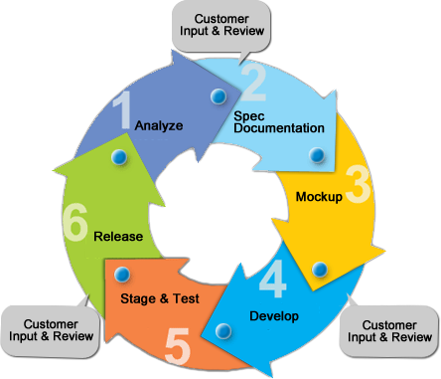
2. UML (Uniform Modern Language)



* UML of students teacher

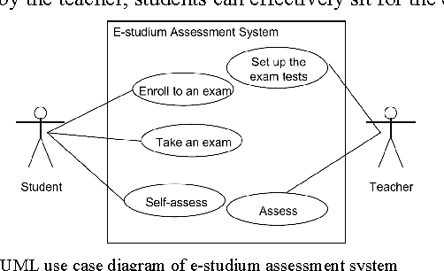

Use Case Name: Registration

Summary :Students enter their details into the system.

Details of the student used to be validated by the system before saving into the database. Actor students

Precondition: Students need to access the system through web browser Main Sequences

1. Students provide their details.
2. System validates customer’s details.
3. System then saves customers' details into the database.
4. System registers new customers.
5. System shows the message after saving the details successfully.

Alternative Sequence N/A

Post Condition: System create account for the new customer. Use Case Name: Login

Summary: Customer enter their username and password to access their account Actor: Customers

Precondition: Customer need to register as a member Main Sequences

1. Customers enter user credentials. 2. System verify users.

3. System redirect to the user page. Alternative Sequences

If customers are unable to login to the system then the system will show customers “Forget Password” link where they can change their password.

* Activity diagram

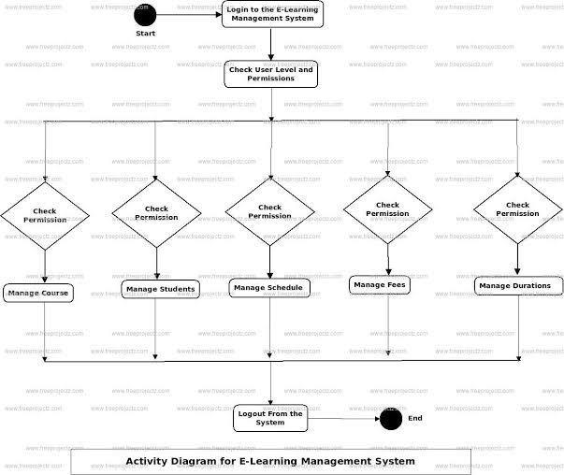

**Login**

* Start
* Registration
* Check Permission
* Manage Student
* Logout from the User
* End

**Sequence Diagram**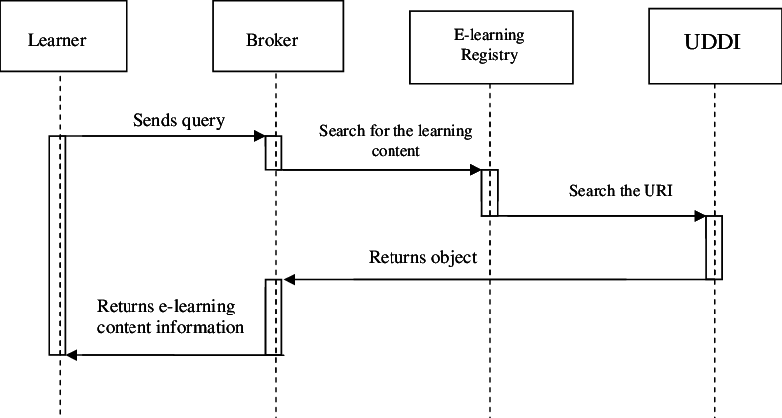

# Software Testing

Testing a program consists of subjecting the program to a set of test inputs and observing if the program behaves as expected. If the program fails to behave as expected then the conditions under which failure occurs are noted for later debugging and correction. Various terms associated with Testing are:

**FAILURE:** It is a manifestation of the error. But the mere presence of an error may not necessarily lead to failure.

**TEST CASE:** It is the Triplet [I, S, O] where I is the data input to the system, S is the state of the system at which data is input, and O is the expected output of the System.

**TEST SUITE:** It is the set of all test cases with which a given software product is to be tested. Software testing is the process used to measure the quality of developed computer software. Testing is a process of technical investigation, performed on behalf of stakeholders, that is intended to reveal quality-related information about the product with respect to the context in which it is intended to operate.

There are essentially two approaches to systematically design the Test Case:

* Black box testing treats the software as a black-box without any understanding as to how the internals behave. Thus, the tester inputs data and only sees the output from the test object. They are designed using only the software specification of the software.

44

* White box testing, however, is when the tester has access to the internal data structures, code, White box testing, however, is when the tester has access to the internal data structures, code, and algorithms. It is therefore also called Structural testing.

**Levels of Testing**

* Unit testing tests the minimal software component, or module. Each unit (basic component) of the software is tested to verify that the detailed design for the unit has been correctly implemented.
* Integration testing exposes defects in the interfaces and interaction between integrated components (modules).
* Functional testing tests at any level (class, module, interface, or system) for proper functionality as defined in the specification.
* System testing tests a completely integrated system to verify that it meets its requirements.
* Alpha testing refers to the system testing carried out by the test team within the developing Organisations.
* Beta testing is the system testing performed by a selected group of friendly customers.
* Acceptance Testing refers to the System testing performed by the customer to determine.

# Conclusion

We are concluding the previous studies of cloud computing is the best solution for all educational institutes and also universities. Cloud computing recently emerged compelling the paradigm for the managing and the delivery of the services over all over the internet. The rise of cloud computing is also rapidly changing information technology and ultimately to turning to long-held promise of the utility of computing in a reality.

The economic situation will force the different education institutions and organizations to consider and adopt cloud solutions. All organizations have kept the gap between the current situation and new development in order to continue offering their services in a sufficient way. The main aim of work was to identify the architecture which will enable the use of cloud computing within higher education. We have considered the benefits of cloud architecture. Even though this dissertation could produce potential outcomes following the research question, there were some limitations, which could be improved in future research. In terms of the users’ perceptions of the bus scheduler. However, there were some issues, which were brought up by the interviewees, such as enhancing customer service and the use by elderly people. Therefore, future research should carry out a case study based on this prototype to examine exact perceptions.

# 10. Future Scope

Smart technologies are rapidly changing the overall educational framework in the country. Did you know that it is projected the online market in India will grow to about $ 1.96 billion by 2021? It is a compound annual growth of about 52% from 2016, when the online education market was worth $247. It is estimated that there is a 175% increase in the cost of classroom education, this makes online education more preferred because it is cost effective.

The penetration of digital education into the hinterland / rural market is evolving fast. The situation in rural areas is troubling – outdated teaching methods, shortage of teachers, inadequate student-teacher ratio, and insufficient teaching resources are some of the issues they are still struggling with. But thanks to affordable high-speed internet and direct-to-device technologies, these are empowering rural students to study courses online and improve their skills and knowledge. Students in educationally backward areas are being taught with the aid of the latest teaching tools and methodologies. Technology has also helped teachers connect with students remotely spread across wide geographical locations. Interactive digital media will certainly help in addressing the shortage of teachers in the country in the near future.

But in a country as diverse as India in terms of regional, linguistic, caste, class and gender, and socioeconomic status, it creates a myriad of problems about specific educational, psychosocial and financial needs of students as well as teachers. A unilateral approach to digital learning isn’t the answer – the transition won’t happen at one-go or be smooth. However, there is tremendous opportunity for growth, and this is the perfect time to tap into it!